Admin : Product Add / Edit Page
Featured Image: 406 x 407 px
Product small image (Thumbnail Image)
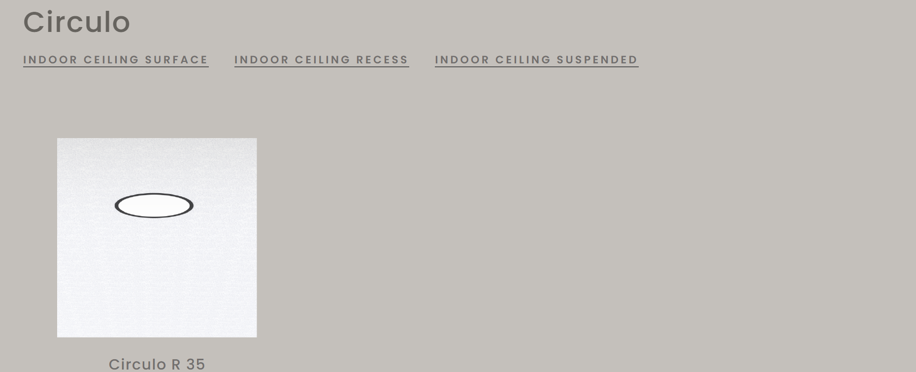
Product Images : (1466 x 826 px)
Header slider of product view page
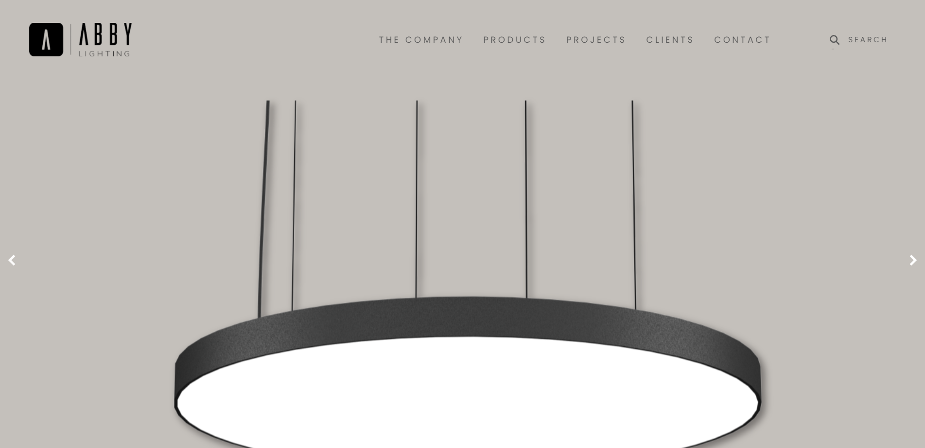

Admin : Product View Page : Add Variant
Line Diagram: 609 x 452 px
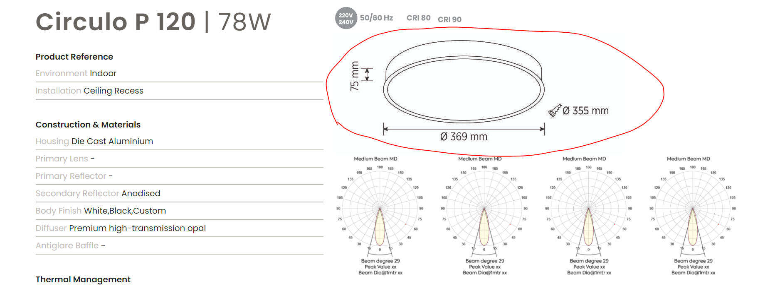
Vector Images: 233 x 306 px
Upto 4 images
